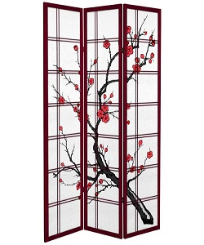

Stylish Divider

$45.75

Availability: In stock

**Description:**

Beautiful printed rosewood glass divider. this room divider can be used to define space in an open concept room, or can be set in front of a large window for privacy. Rounding out the design, metal hinges make folding and storage a breeze when not in use.